Web data extraction Requirement document

Suggested Code Policy:

1. Copy the Project folder structure from bellow github link.

<https://github.com/pool23/pool_UK>

1. Use Python(Mandatory) with BeautifulSoup, Scrapy and Selenium (Feel free to use any other Python libraries)
2. Store Scrapped data with provided file name and CSV format.

Work 1:

**Scarped Data Format (File Name - Metro_Data_Deposit_<YYYY_MM_DD>.csv)**

|  |  |
| --- | --- |
| **Column NAMES for Deposits** | **Default Values** |
| Date | Date(YYYY-MM-DD) |
| Bank_Native_Country | UK |
| State | London |
| Bank_Name | Barclays Bank |
| Bank_Local_Currency | GBP |
| Bank_Type | Bank |
| Bank_Product | Deposits |
| Bank_Product_Type | SCRAPED DATA - Format should be Savings/Current/Term Deposits |
| Bank_Product_Name | SCRAPED DATA |
| Min_opening_Bal | SCRAPED DATA |
| Balance | SCRAPED DATA |
| Bank_Offer_Feature | Offline by default and Online where product name has keyword Online |
| Term in Months | SCRAPED DATA |
| Interest_Type | SCRAPED DATA - Default is Variable |
| Interest | SCRAPED DATA |
| AER | SCRAPED DATA |
| Bank_Product_Code | LEAVE THIS COLUMN BLANK |

[**https://www.barclays.co.uk/savings/instant-access/**](https://www.barclays.co.uk/savings/instant-access/)

**Savings**

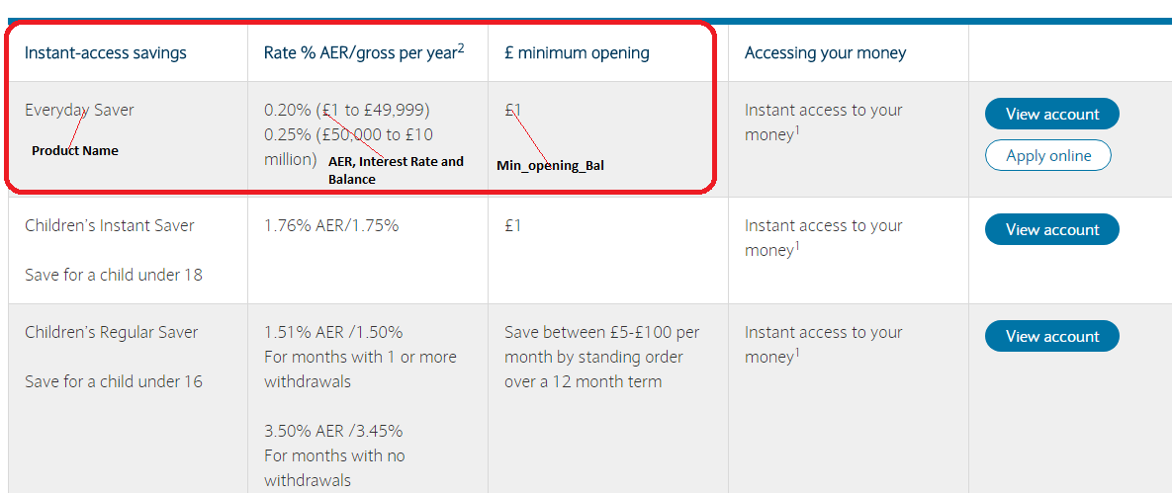

[**https://www.barclays.co.uk/savings/isas/**](https://www.barclays.co.uk/savings/isas/)

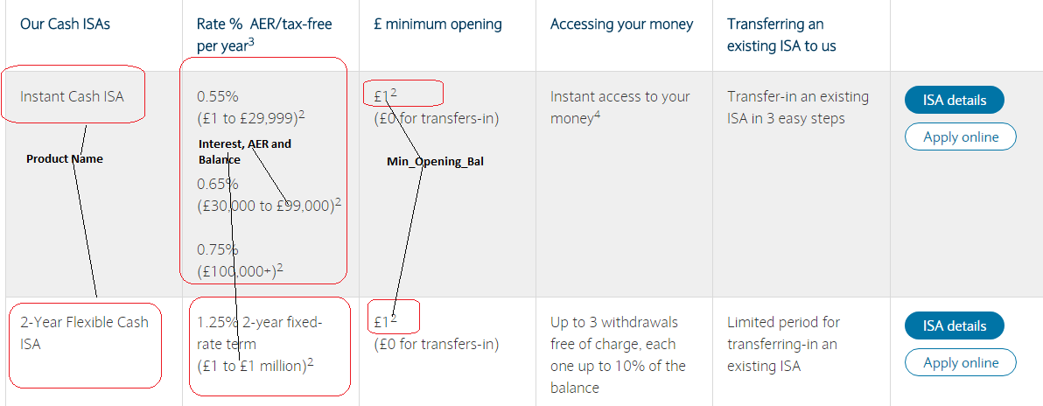

**Term Deposit**

**https://www.barclays.co.uk/savings/bonds/**

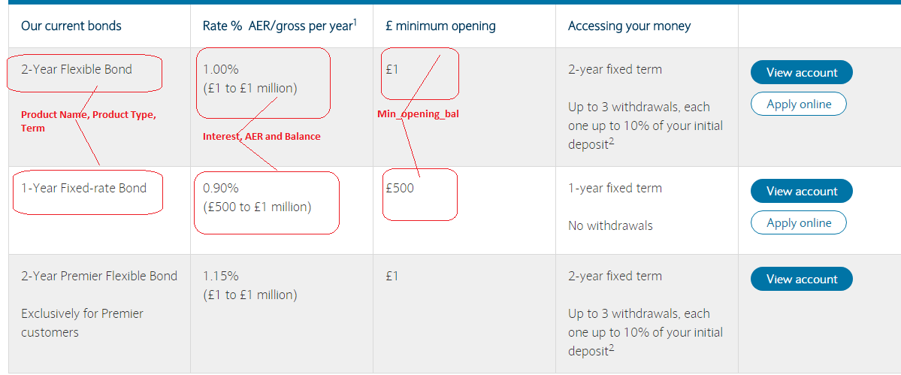

**Repeat it for all products**

**Current Account:**

<https://www.barclays.co.uk/current-accounts/>

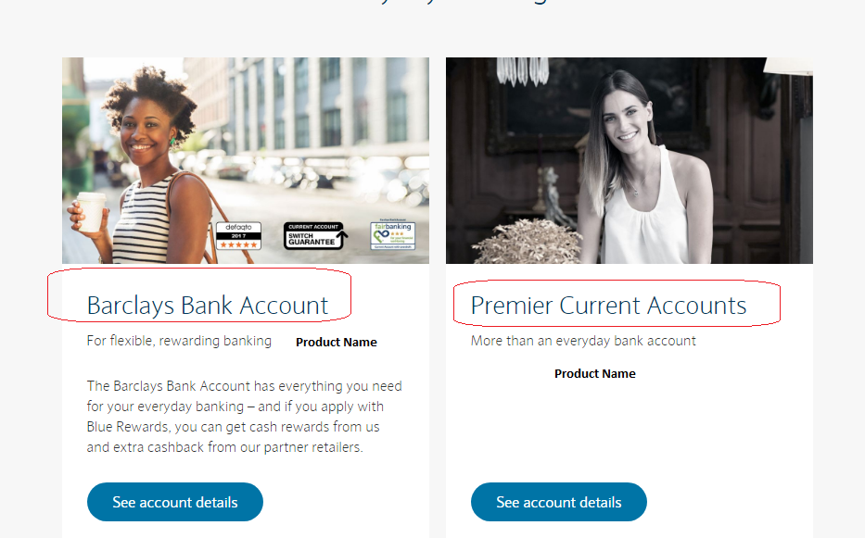

Work 2: Mortgage Rates

|  |  |
| --- | --- |
| **Mortgages Columns** | **Default Values** |
| Date | Date(YYYY-MM-DD) |
| Bank_Native_Country | UK |
| State | London |
| Bank_Name | Barclays Bank |
| Bank_Local_Currency | GBP |
| Bank_Type | Bank |
| Bank_Product | Mortgages |
| Bank_Product_Type | Mortgages |
| Bank_Product_Name | SCRAPED DATA |
| Min_Loan_Amount | SCRAPED DATA |
| Bank_Offer_Feature | Offline |
| Term (Y) | SCRAPED DATA |
| Interest_Type | SCRAPED DATA (Variable, by default) |
| Interest | SCRAPED DATA |
| APRC | SCRAPED DATA |
| Mortgage_Loan_Amt | SCRAPED DATA |
| Mortgage_Down_Payment | 20% |
| Mortgage_Category | New Purchase |
| Mortgage_Reason | Primary Residence |
| Mortgage_Pymt_Mode | Principle + Interest |
| Fixed_Rate_Term | SCRAPED DATA <from title> |
| Bank_Product_Code | LEAVE THIS COLUMN BLANK |

Case 1: Property Value: 90,000; Your deposit: 18,000; Loan Amount: 72000

Case 2: Property Value: 270,000; Your deposit: 54,000; Loan Amount: 216,000

Case 2: Property Value: 450,000; Your deposit: 90,000; Loan Amount: 360,000

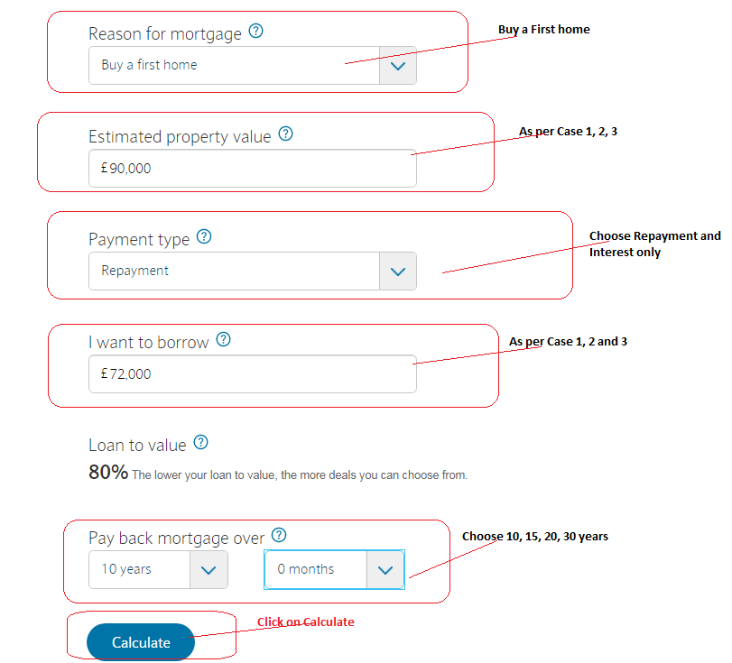

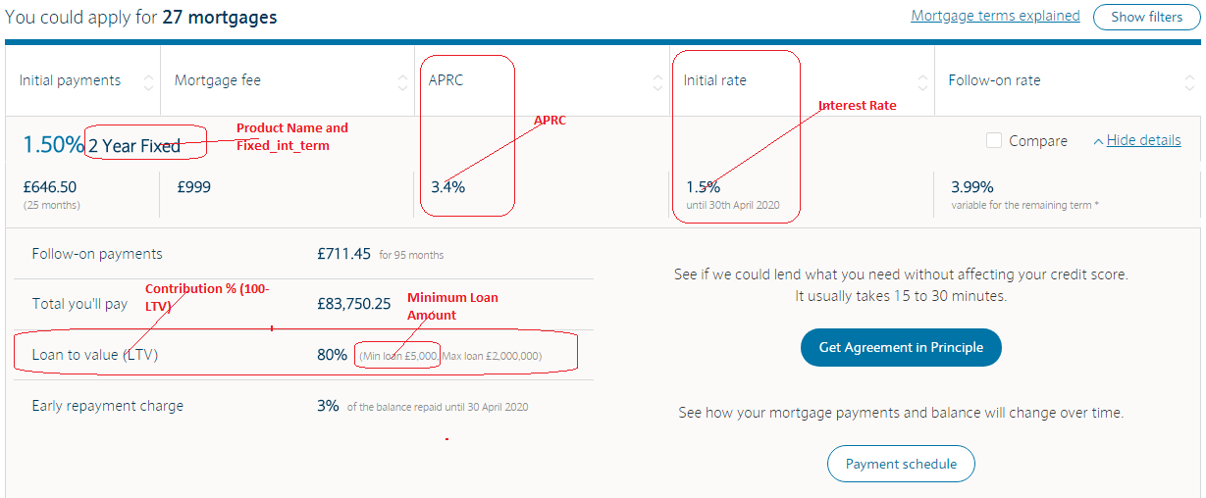

Scrape for all 27 output

Repeat for 10, 15, 25, 30 year loan term

**Example for 1st Product:**

Product Name: 2 years Fixed

Term: 10

Fixed_Rate_Term: 2

Mortgage_Down_Pymt: 20%

Interest: 1.50%

APRC: 3.4%